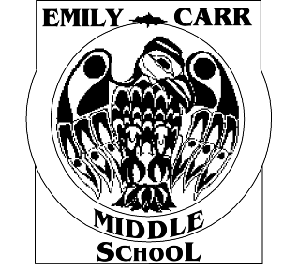 | 2681 Innes Road, Ottawa, Ontario K1B 3J7  Phone: 613-824-5455 Fax: 613-824-0487  Principal: Marc Slesar  Office Administrator: Karen Green  Office Assistant: Tammie Taylor | 

EMERGENCY / EARLY CLOSING ARRANGEMENTS FOR 2023-2024 SCHOOL YEAR

If there is an emergency and the school must be closed early, our evacuation site is Glen Ogilvie P.S., 46 Centrepark Dr., 613-824-4014.
If your child is a bus student, bussing will be provided; however drop off will not be at the usual time. You will be contacted to ensure that someone will be home to meet your child.
Name of Student: _______________________ Teacher: ___________________________

Please include siblings, if appliciable, here:

Student: _______________________________ Teacher: ___________________________

Please choose one of the following…
If the school is closed early, my child(ren) will:

□ Walk home as usual* □Take bus home as usual (time of drop off TBD)

□ Walk to sitter/neighbor/re lative/friend* __________________________________________
Name of person & their phone number

□ Wait to be picked up by _____________________________________________________
Name of person & their phone number
* If conditions outdoors make it unsafe for my child(ren) to walk home or to a sitter/neighbor/relative/friend and this is the option I have chosen above, the alternate arrangement is:

_____________________________________________________________________________

I have reviewed the above procedure with my child(ren) and authorize the staff of Emily Carr MS to contact the person indicated above.

Parent/Guardian Signature: ________________________________
Emergency phone number: ________________________________

Please return this form to your child’s classroom teacher by Friday, September 22, 2023. Thank you!

