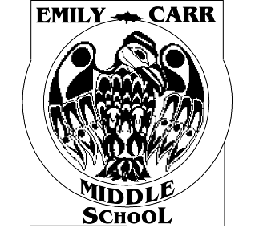 | 2681 Innes Road, Ottawa, Ontario K1B 3J7  Phone: 613-824-5455 Fax: 613-824-0487  Principal: Marc Slesar  Office Administrator: Karen Green  Office Assistant: Tammie Taylor | 

September 5, 2023

Dear parents/guardians,

Welcome to a new school year. This form is a reminder that we want all students to learn in a safe and healthy environment. Please do not send nut products to school as many of our students have life-threatening allergies. The only way to provide a safe environment for these children is to make our classrooms free of these products.
Please:
-check the ingredients of all the food your child(ren) bring to school
-discourage any sharing or trading of food
-encourage hand washing before and after eating

Food does not have to be eaten to cause an allergic reaction and cross-contamination is a constant concern with food allergies. Cross-contamination occurs when a few crumbs from one child's snack are dropped and then picked up by a child with an allergy to that food, or residue is left on desk tops. Even a small amount can be life-threatening!

We greatly appreciate your understanding regarding the seriousness of this condition and thank you in advance for assisting us in our efforts to create as safe an environment as possible for all of our students. With your cooperation, we can minimize the risk of allergic reactions.

Please acknowledge that you have read the above by completing the required information below and return to the homeroom teacher by September 22, 2023.

Sincerely,
Marc Slesar
Principal
Emily Carr Middle School

Student’s name: _________________________________________

Homeroom teacher’s name: __________________________________

